1. IAM – IDENTITY ACCESS MANAGEMENT (SECURITY IDENTITY AND COMPLIANCE)

* 1. How does IAM dashboard look like ?  
       
     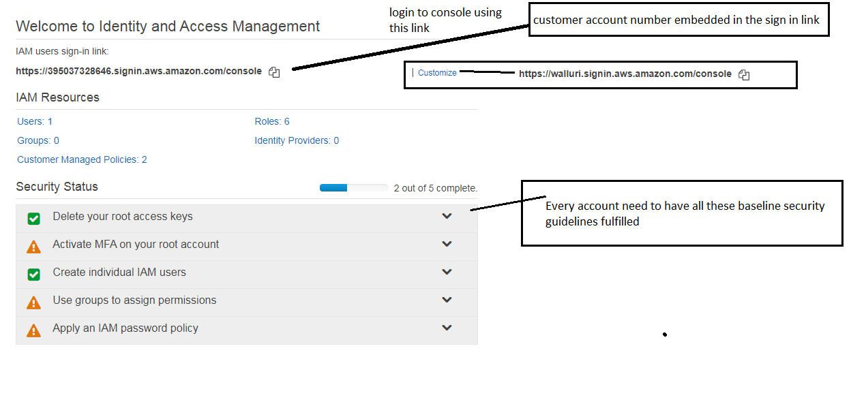
  2. Adding user.  
     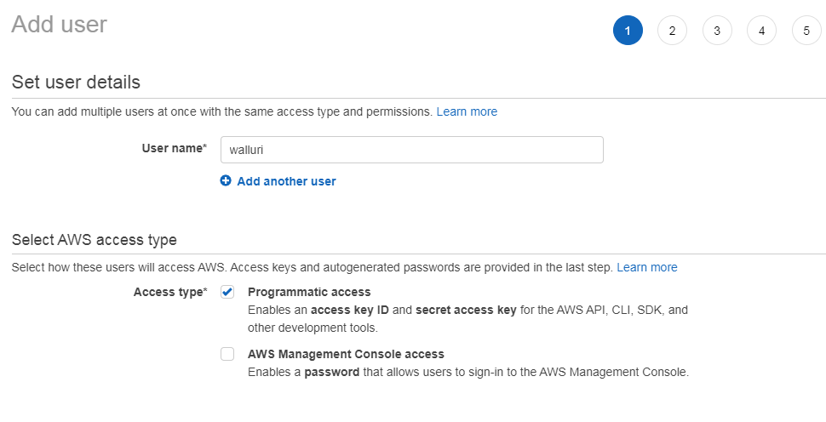  
        
       
     When using console access for a user – below options are shown.  
       
     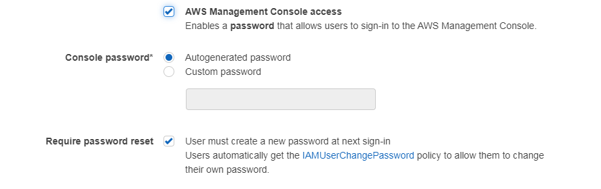  
       
       
     Set permissions for the new user – Walluri  
       
     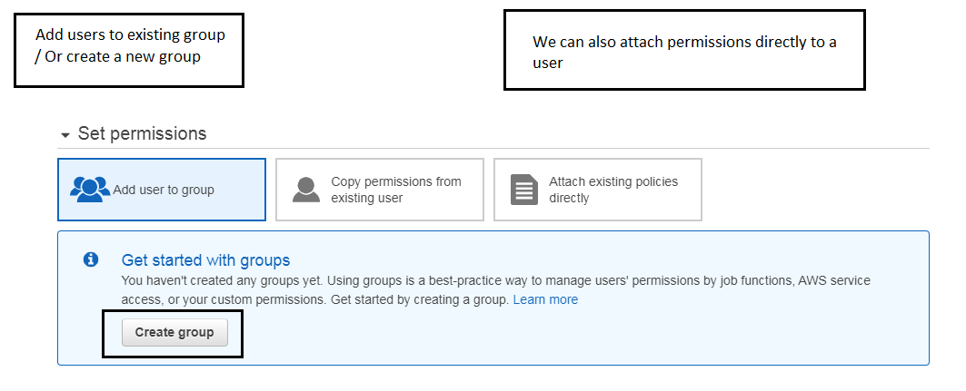

Create a new group.  
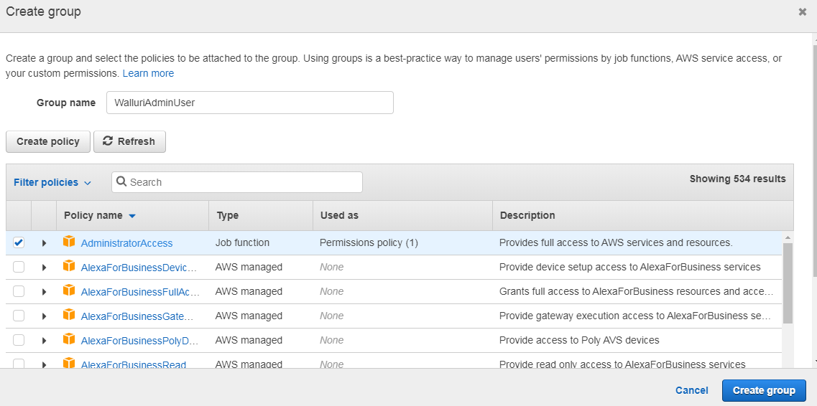  
  
What does the Administrative Access Policy look like.  
It allows all kind of actions on all resources.  
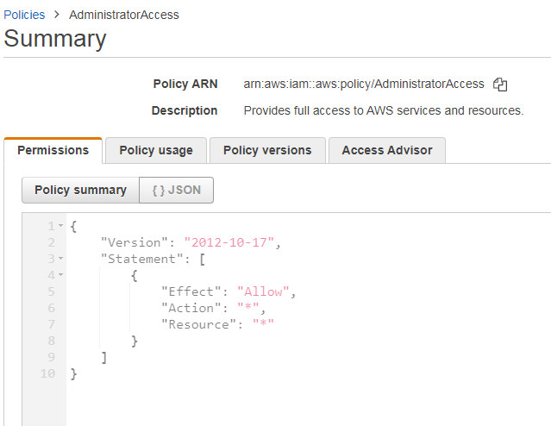

Final window before creating user and the group associated with it.  
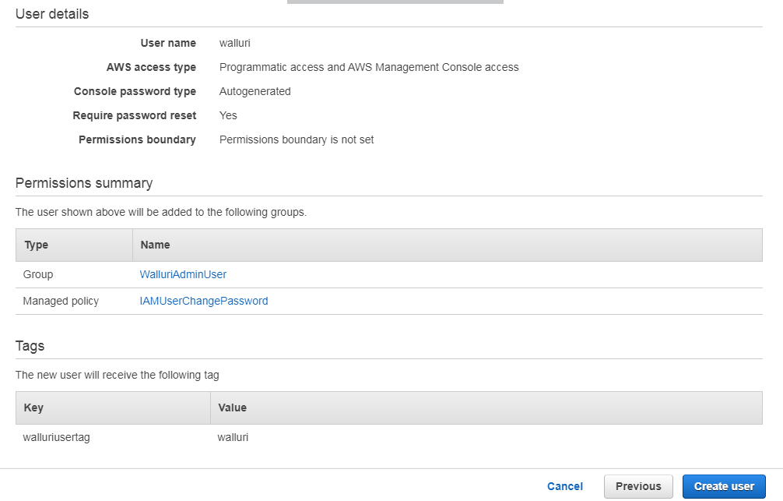

After Creating user.

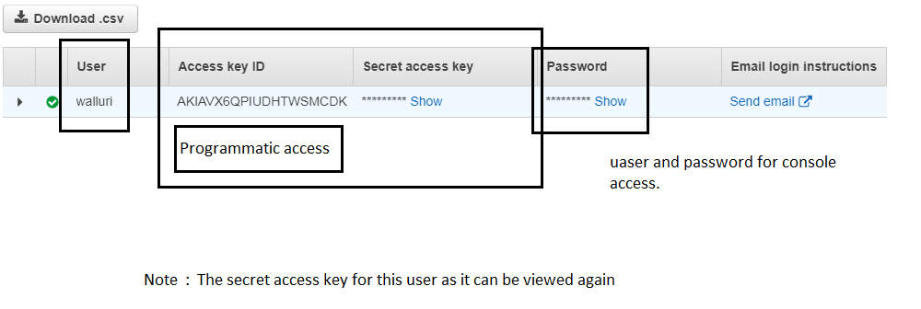

You can also create groups and attach amazon policies for it.  
And add a user to a group.  
  
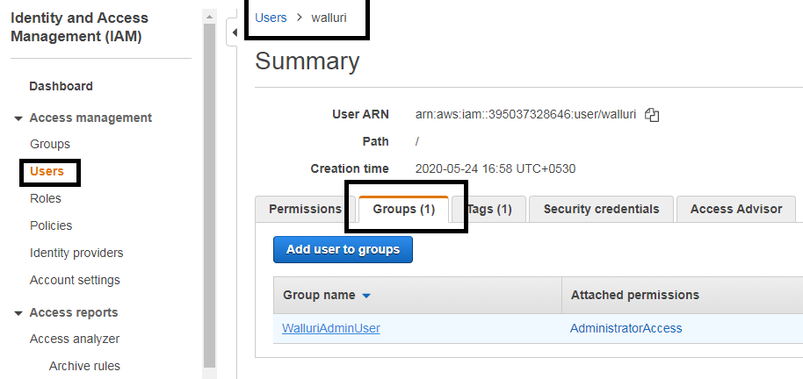

And user can get certain permissions without being part of a group.  
  
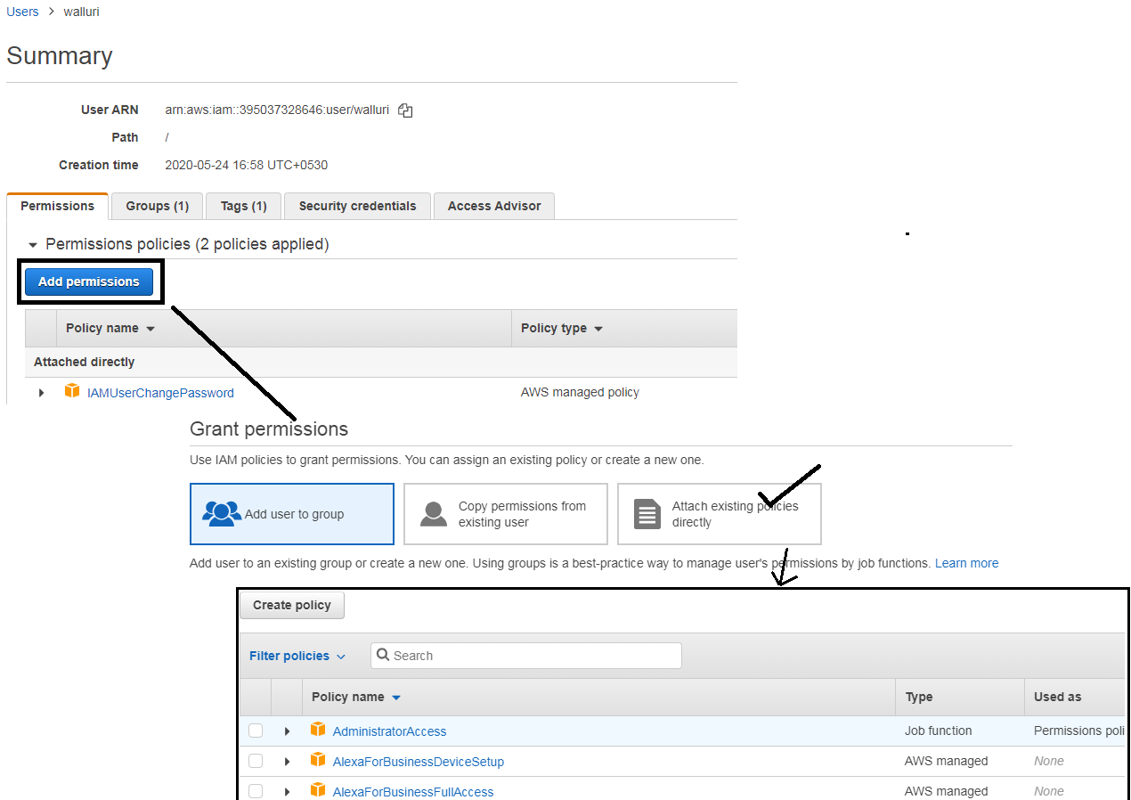

We can also Create a ROLE.  
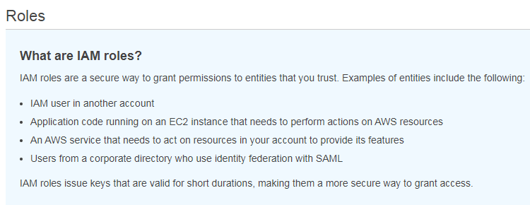  
  
  
  
  
Using Roles we can grant permission to an entity for an user/application/service to access.  
  
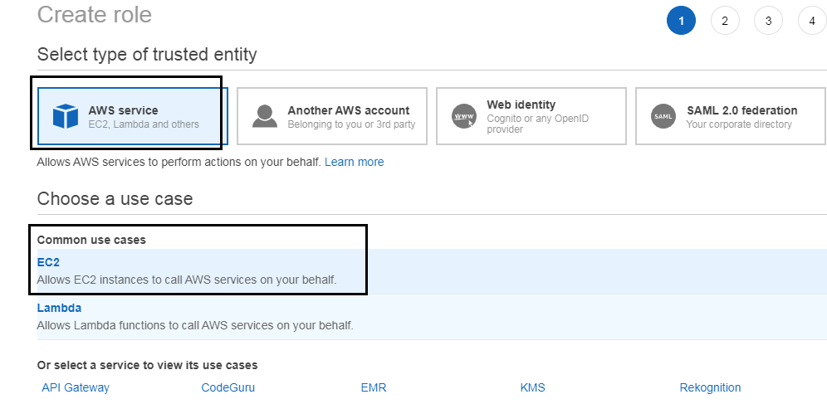

So, Any EC2 instance which has this role attached: will have full access to S3.  
  
  
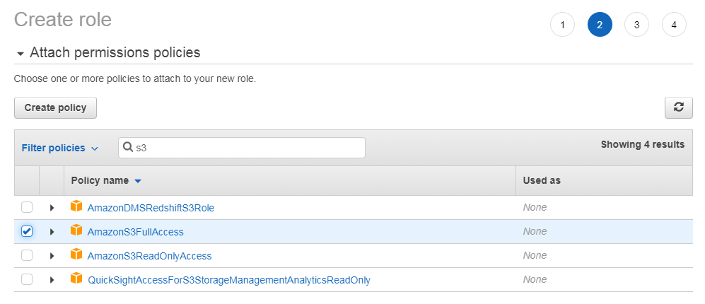  
  
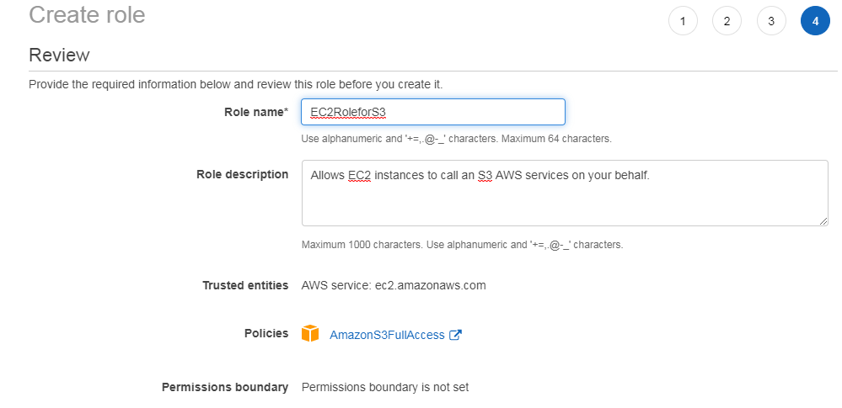

Now that we created a role we can apply this role to an EC2 instance which needs s3 full access.

2. EC2 ELASTIC CLOUD COMPUTE (COMPUTE)

2.1 Different types of EC2 instances

|  |  |  |
| --- | --- | --- |
| Family | Specialty | Use cases |
| F | **F**IELD PROGRAMMABLE GATE ARRAY | GENOMICS RESEARCH. FINANCIAL ANALYTICS. REAL TIME VIDEO PROCESSING. BIG DATA. |
| I | **I**NTENSICE/HIGH SPEED STORAGE | DATA WAREHOUSING. NoSQL DB’s. |
| G | **G**RAPHICS INTENSIVE | VIDEO ENCODING. 3D APPLICATION STREAMING |
| H | HIGH DISK THROUGHPUT | MAP-REDUCE BASED WORKLOADS. HDFS. MapR-FS |
| T | *Timepass*, LOW COST | WEB SERVERS. SMALL DATABASES. |
| D | DENSE STORAGE | DATA WAREHOUSING. HADOOP. FILESERVERS |
| R | *Ram*,MEMORY OPTIMIZED | MEMORY INTENSIVE APPS |
| M | *Mnc*(multi national company) MEMORY,COMPUTE,NETWORK balanced | APPLICATION SERVERS |
| C | COMPUTE OPTIMIZED | CPU INTENSIVE APPS |
| P | G ***P*** U | MACHINE LEARNING. BIT COIN MINING. |
| X | MEMORY OPTIMIZED | SAP HANA / APACHE SPARK. |
|  |  |  |

|  |  |  |
| --- | --- | --- |
| General Purpose | ATM | * These instances provide a balance of compute memory and network resources * Ideal for applications that use resources in equal proportions * Ex: Web servers and code repositories. |
| Compute Optimized | C | * Compute optimized instances are ideal for compute bound applications, which use high performance processors. * Used in batch processing workloads,media transcoding, high performace web servers, high performace computing, scientific modelling,dedicated game server, machine learning inference and other compute intensive applications. |
| Memory Optimized | RXZ | * Memory optimized instances are designed to deliver fast performance for workloads that process large data sets in memory. |
| Accelerated computing | PF Inf G | * Accelerated instances use hardware accellarators OR co-processors to perform functions such as floating point number calculations, graphics processing, or data pattern matching, MORE EFFICIENTLY THAN DONE BY A CPU. |
| Storage optimized | HID | * Storage optimized instances are designed for workloads that require high, sequential read write access to very large data sets on local storage * They are optimized to deliver tens of thousands of low latency, random i/o operations per second (IOPS) to applications. |
|  |  |  |

2.2 How does EC2 launch page look like ?  
  
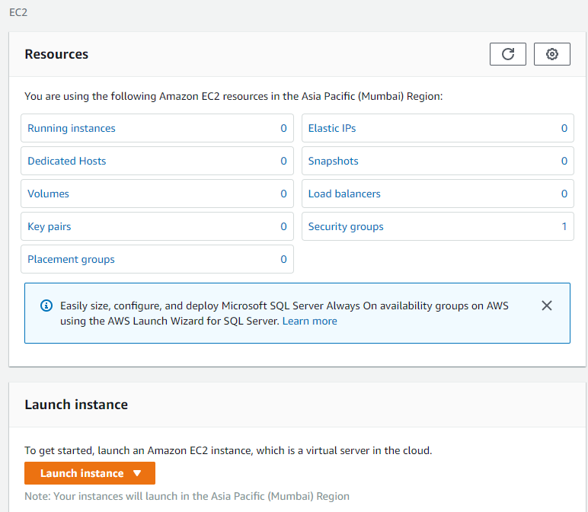  
  
  
CHOOSE AMI  
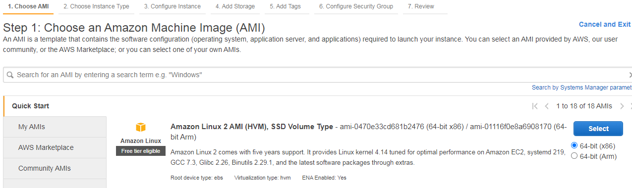

CHOOSE INSTANCE TYPE  
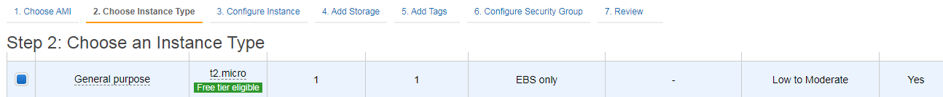

CONFIGURE INSTANCE  
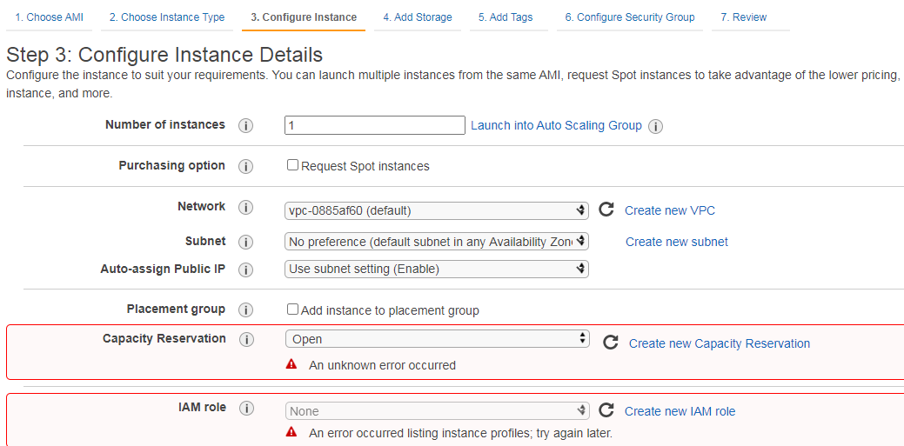

---  
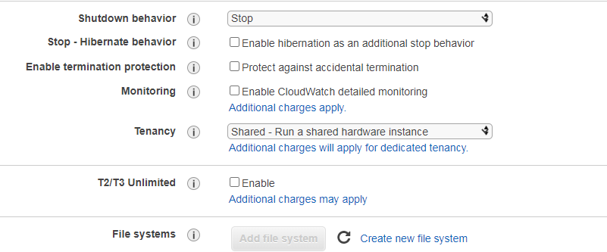  
----  
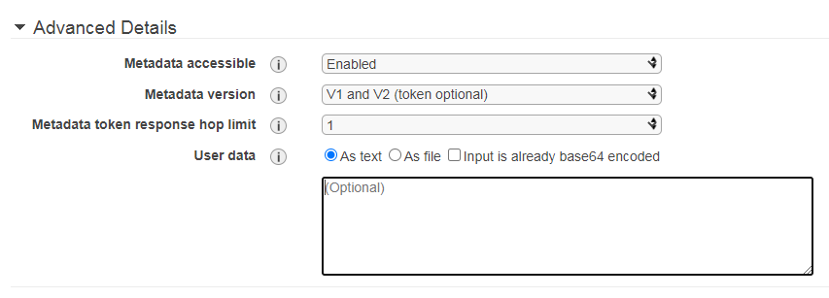  
User Data : Bootstrap scripts.  
  
Monitoring : Detailed monitoring monitors every minute as opposed to every 5 minutes using CLOUD WATCH..

Tenancy: 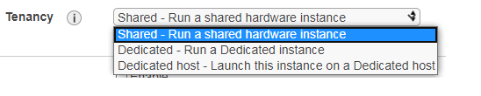  
  
ADD STORAGE:  
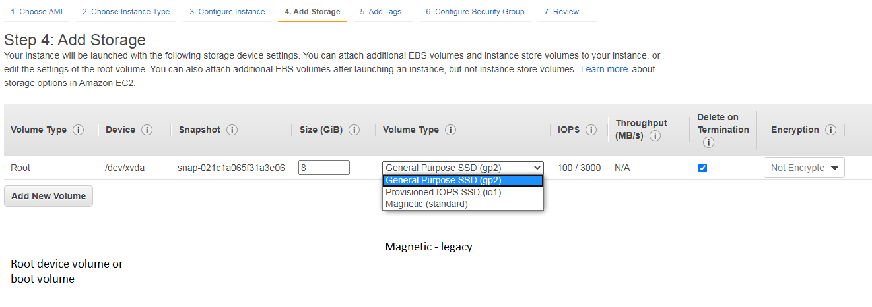  
  
You can additional volumes also.  


ADD TAGS.  
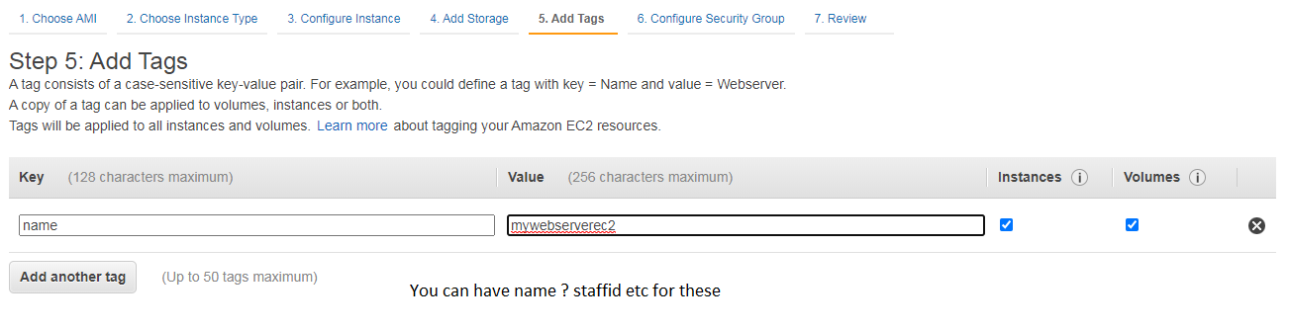

CONFIGURE SECURITY GROUPS.  
- Its like a virtual firewall and it allows traffic in and out of our instance.  
- If it’s a web server people access http port 80.  
- Allow a person from anywhere to connect to our webserver via ssh/http/https.

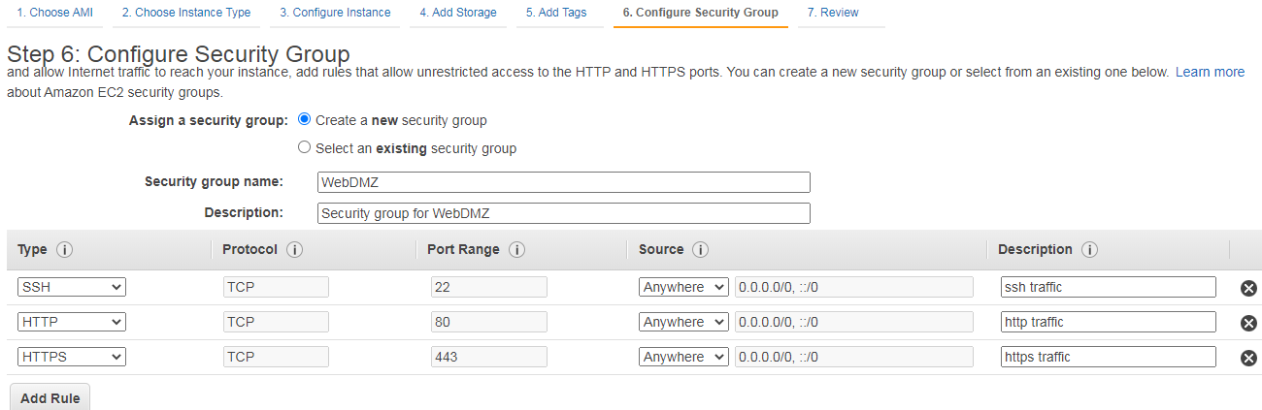

LAUNCH.These key pairs are **regional.**We prevent other people from connecting by literally locking using the key pair.  
Public key : the lock.

Private key : the key to the lock  
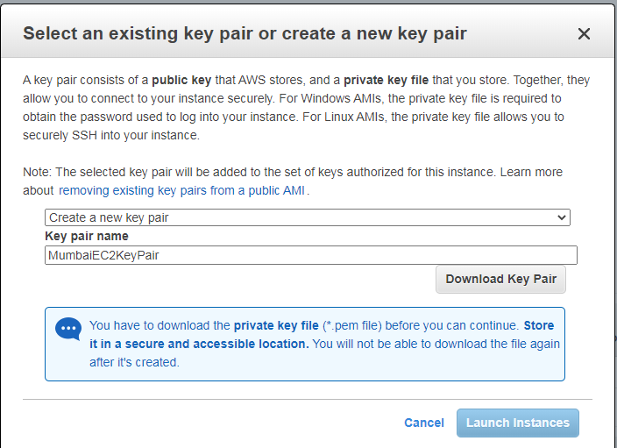  
  
CONNECT TO THE INSTANCE.  
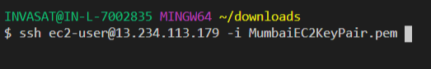

USING THE INSTANCE.  
- yum update -y. // update the OS  
- yum install httpd //to install apache

- service httpd start //start the service

- chkconfig httpd on // start the service even after the instance re-boots.

3. Route53 (Networking and Content delivery)

3.1 What is Route53.  
 It is amazons DNS service, where you can buy a domain name and….  
 It allows you to map your Domain Names with – EC2 instances.  
 – Load Balancers.  
 – S3 Buckets.  
3.2 Register a domain.  
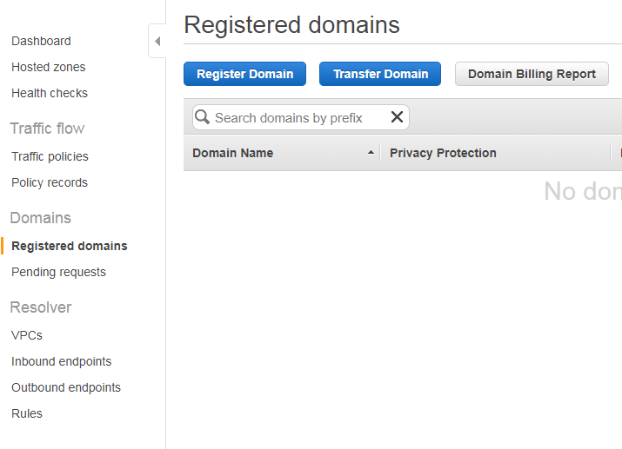  
Hosted zones will show the domain you have purchased.  
If you selected your domain now, We can create a record set.  
Record Set : When *domainname.com* is going to go.[something like a telephone directory]

A Record – ipv4 address  
AAAA Record – ipv6 address

Naked domain Name : domainName.com rather than www.domainName.com.  
  
We create an Alias for the naked domain name.  
Alias only supports for A and AAAA record sets.  
Alias Target : ELB [Application/network/classic]  
 Cloud Front Distributions  
 Elastic Bean Stack Environments …etc

So the way it works is   
domainName.com 🡪 Elastic Load Balancer 🡪 EC2 Instance.

3.3 Create an ELASTIC LOAD BALANCER IN FRONT OF AN EC2 INSTANCE (and later configure route53 alias to point to this LB).

Go to the bottom left in the EC2 home page and create a load balancer.  
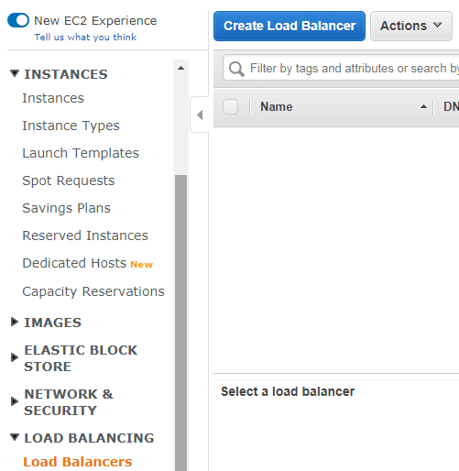

There are 3 types of load balancers.  
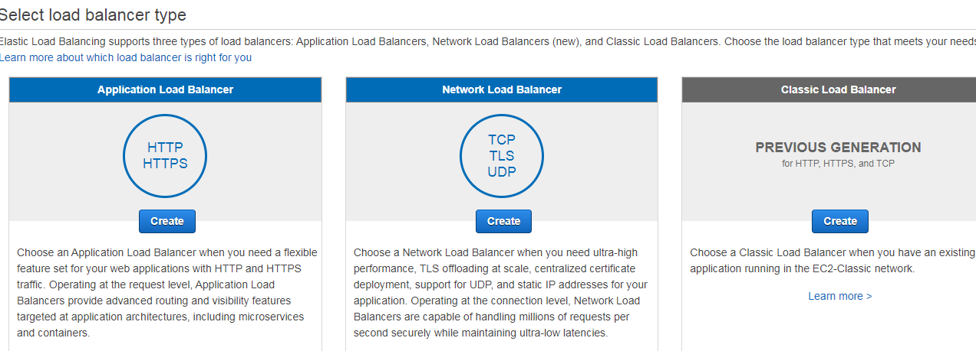

You will be charged per hour and based on LCU.  
(Load balancer capacity units.  
LCU is measured based on New Connections per sec,  
active connections per min,  
Bytes processed in Gb for http(s) req and res,  
Number of rules processed by your load balancer and the request rate.  
)

Creating a load balancer  
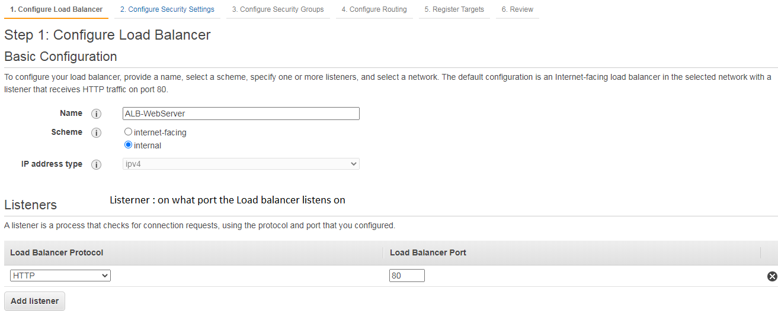  
  
  
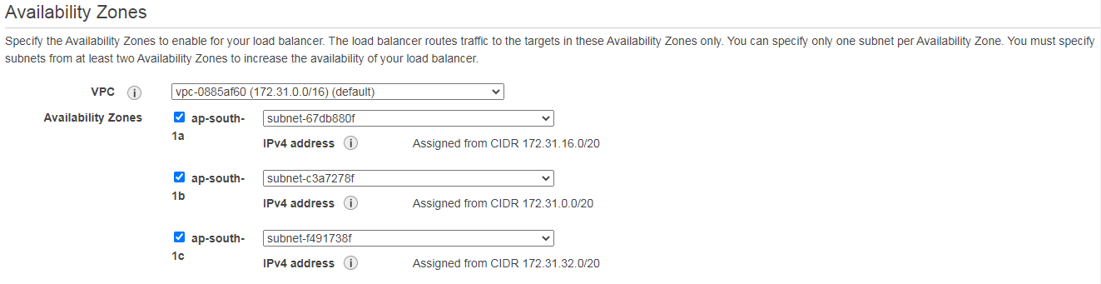  
  
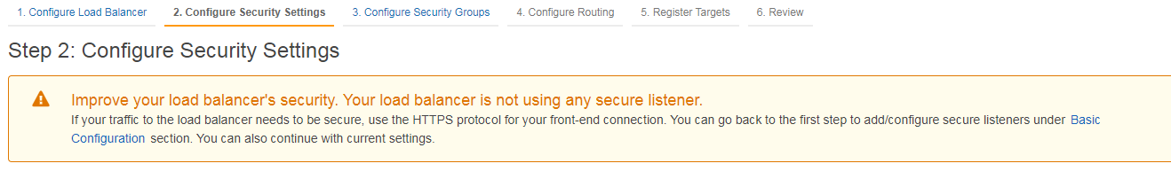  
  
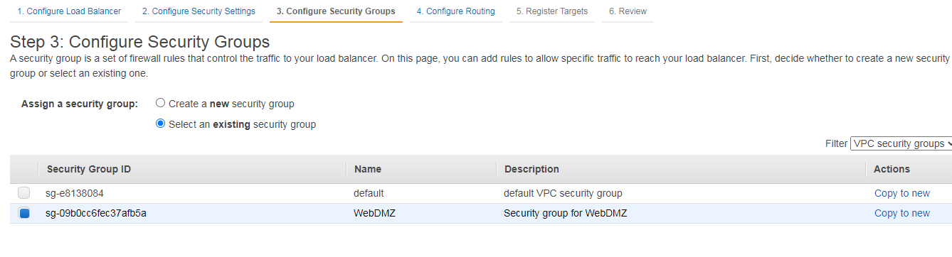  
  
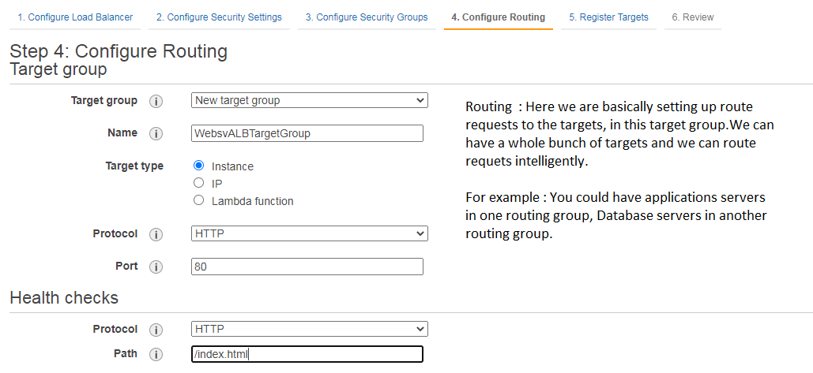

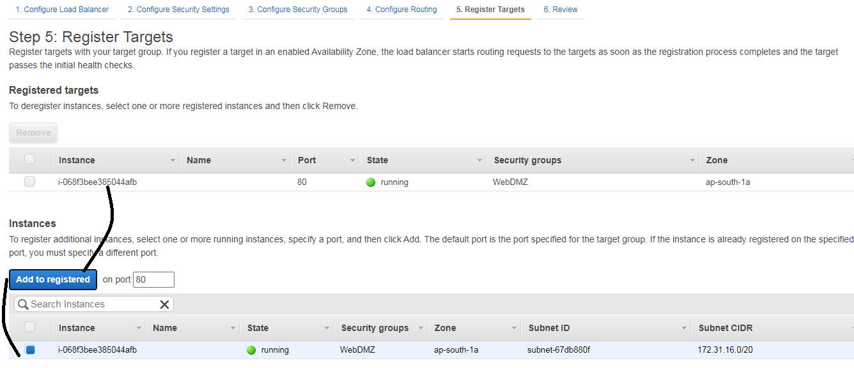

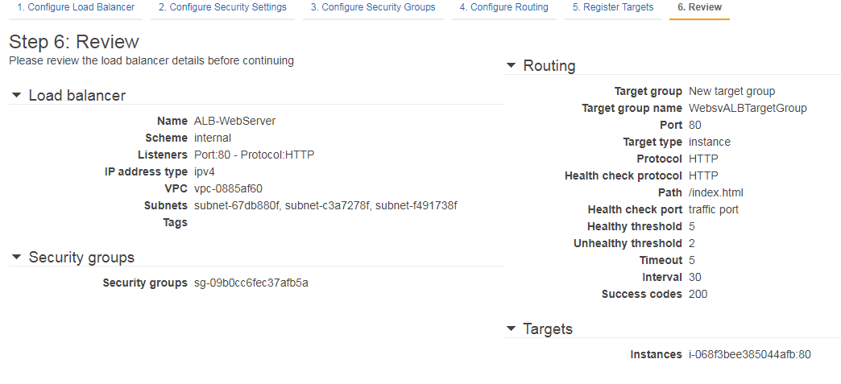  
  
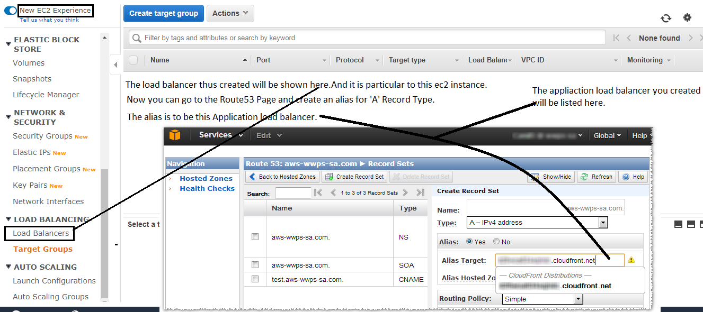  
  
  
List of load balancers will be shown below, pic taken from internet.  
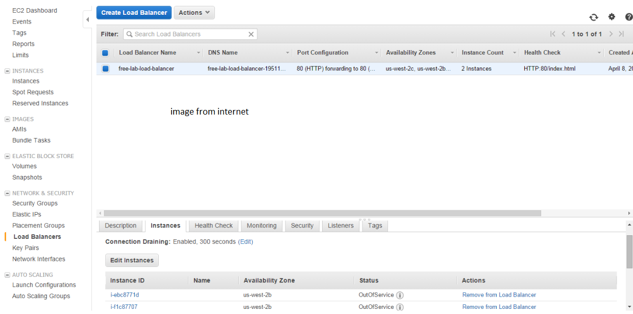  
  
  
4 . EC2 WITH S3 ROLE

4.1 Interact with AWS using the CLI inside the EC2 instance.

//Enter into the ec2 instance via ssh  
 > ssh ec2-user@13.234.113.179 -i MumbaiEC2KeyPair.pem  
  
 using the commandline in the ec2 instance to login in as an aws user to interact with aws resources  
 > aws configure  
  
 List all s3 buckets  
 >aws s3 ls  
  
 remove a bucket .  
 > aws s3 rb s3://s3portfolioartifacts  
  
 Create a bucket .  
 > aws s3 mb s3://valluris3bucket  
  
 Create a file and copy that file to the bucket created above.  
 > echo “hello world from aws” > hello.txt  
 > aws s3 cp hello.txt s3://valluris3bucket  
  
You can see the contents of S3 and the contents of your s3 bucket.  
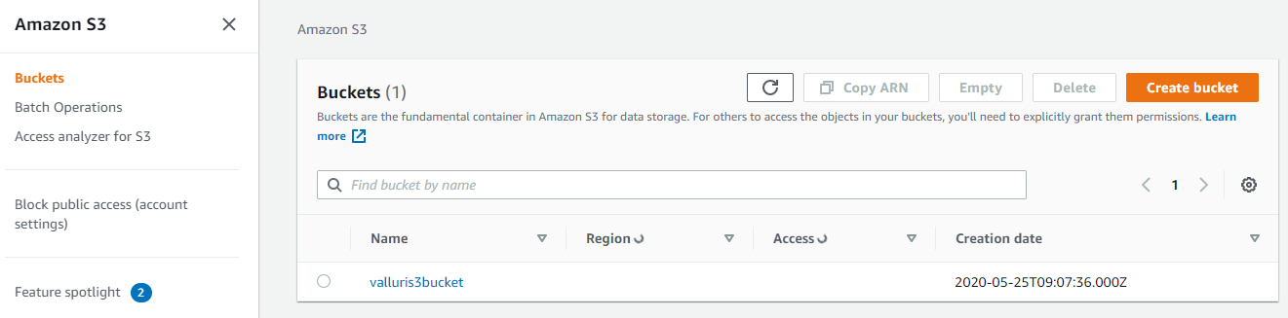  
  
  
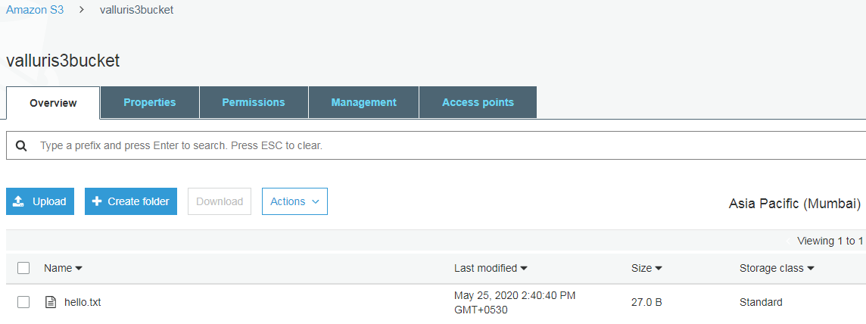  
  
Clicking on the file will show the below options.  
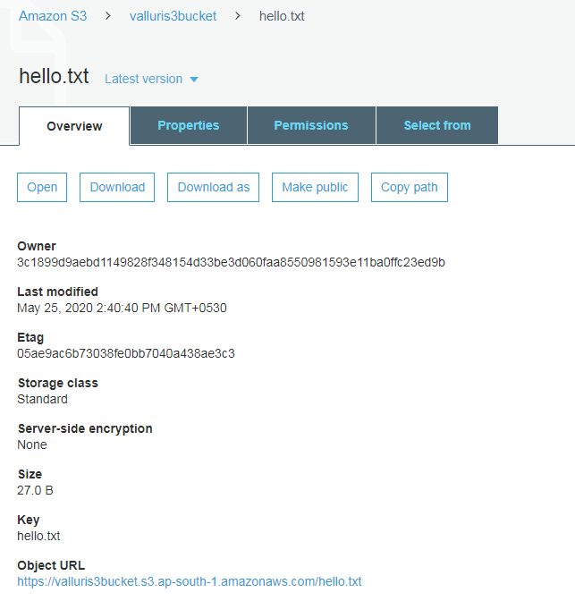  
  
If the file is not public the object URL will not work.  
Now lets delete the access key id and secret access key of the **user,**who is also configured/used in the EC2 instance.  
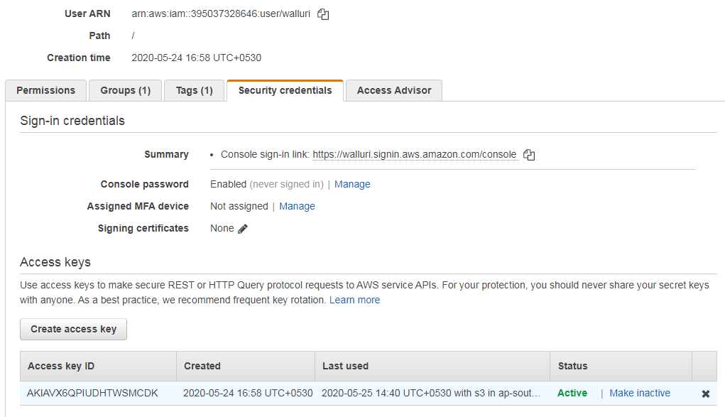

4.2 Now, EC2 with S3 role – how to configure.  
Using Role : lets grant ec2 entity s3 access

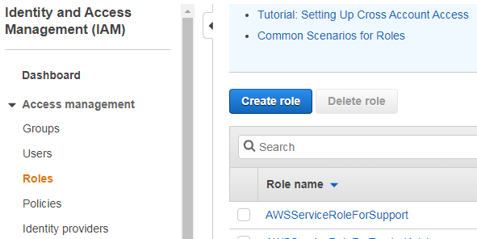  
  
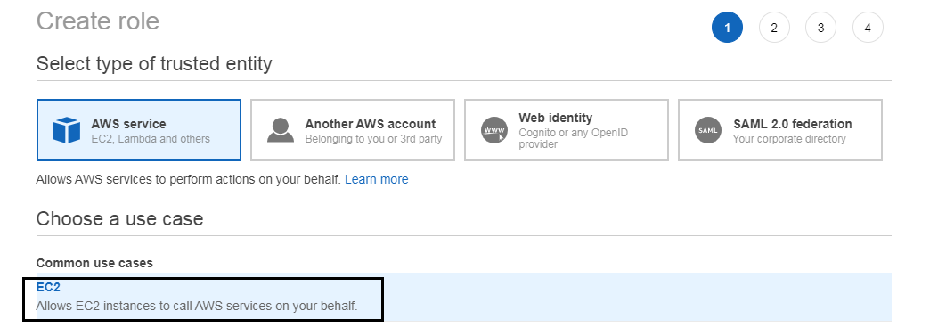  
  
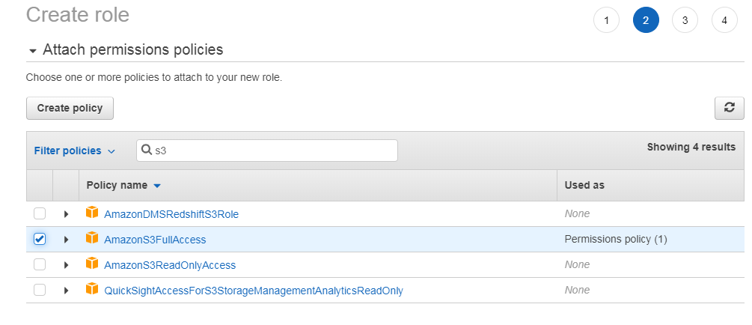  
  
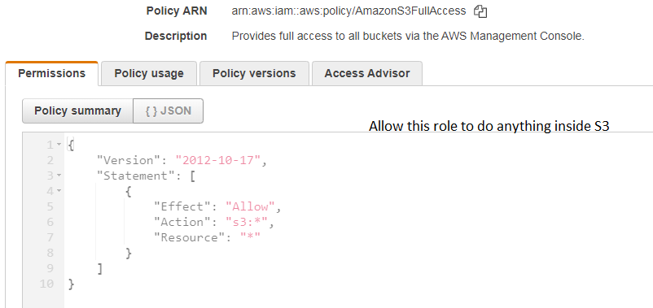  
See if the role is created.  
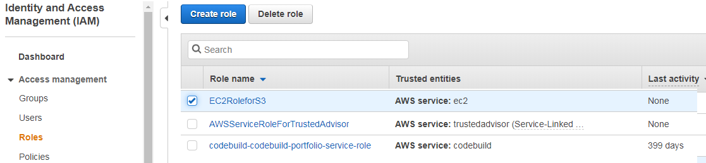  
Attach this role to EC2 instance.  
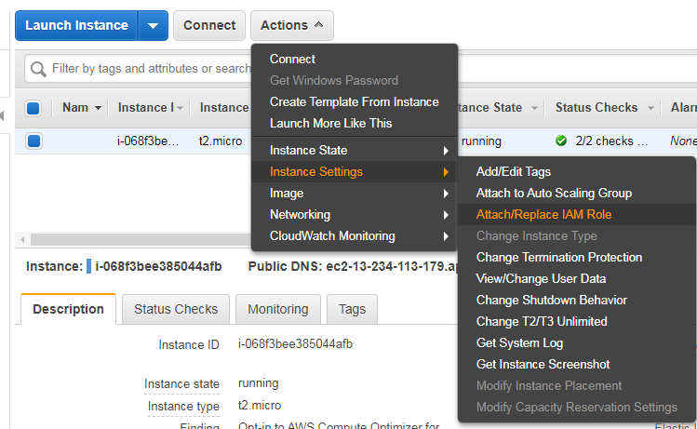  
  
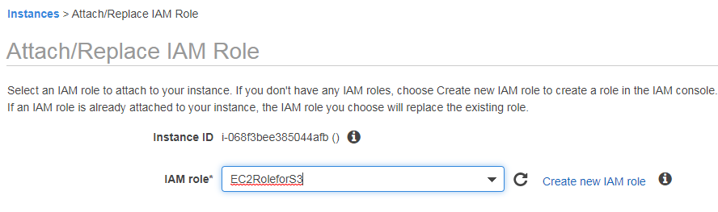

The IAM role list box will only populate with EC2 roles no Lambda roles will be visible.  
Now check if you can access s3 buckets from ec2. 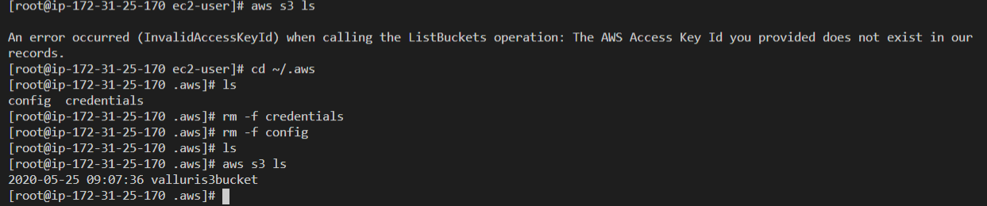

5. Introduction to RDS – Relational database service .

Different Relational Database types – 6 different instances we can provision in RDS.  
  
(MOM - PAM)  
Microsoft SQL Server .  
Oracle.  
MySQL Server.  
PostgreSQL.  
Amazons Aurora (compatible with MySQL).  
MariaDB.  
  
Data Warehousing :  
Used for Business Intelligence by tools like Cognos,JasperSoft,SQL Server,Reporting Services, Oracle Hyperion, SAP NetWeaver.  
These tools pull in very large and complex data sets and should not be performed in a production server.  
Normally the production server sends logs into the dwh .

OLTP vs OLAP [Online Transaction/Analytics Processing.]  
The difference lies in the types of queries you run.  
  
OLTP.  
When a consumer orders : The database will have a new entry about the user who ordered, the item, the price at which he ordered, the address of delivery, the status, the date of order etc.  
i.e a row of data will be written to the database. Simple Transactions.

OLAP.  
Complex.

If you want to figure out the net profit for AMEA and Pacific.  
We have to pull out large number of records, i.e   
Find out number of radios sold in each area,  
The SP of each radio.. etc

DWH databases use different type of architecture both from a database perspective and physical infrastructure layer – to maximize the performance for these types of queries..

Elasticache  
Elasticache is a web service that makes it east to deploy operate and scale – an in memory cache in the cloud.  
The service improves the performance of web-applications by allowing the developer to retrieve information from fast-managed-inmemorycaches instead of relying on slower disk-based databases.  
Ex: If you want to see the top 10 items in a category which are on sale.  
 We don’t want to retrieve this from the database every single time.

Elasticache Supports 2 in-memory caching engines.  
MemcacheD  
Redis.

6. RDS LAB (Create a db and connect from ec2).

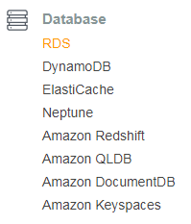  
  
 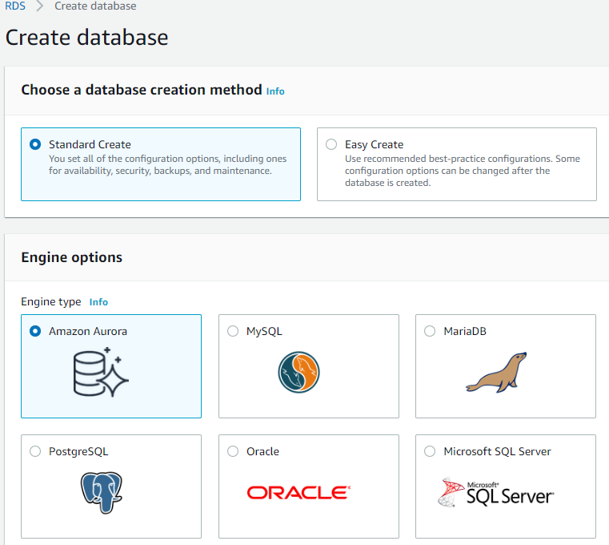  
IF Amazon Aurora is selected, Note that there is no free tier.[Oracle also no free tier.]  
  
 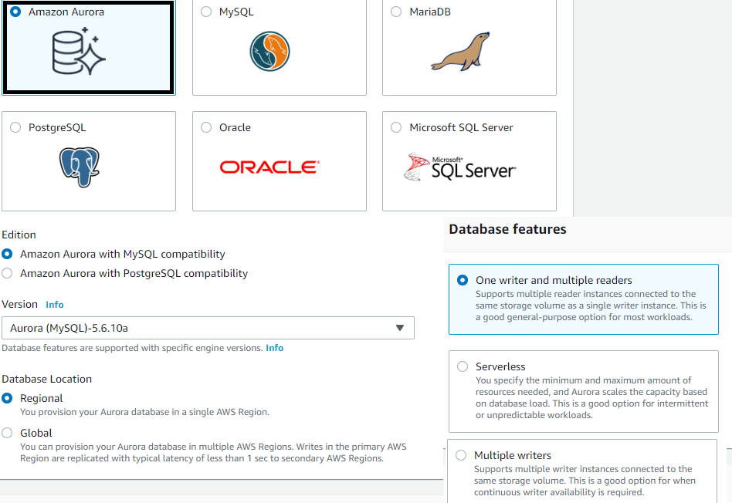  
 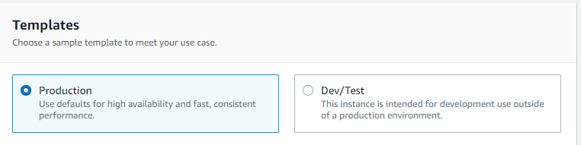  
  
If My SQL is selected, There is a free tier.  
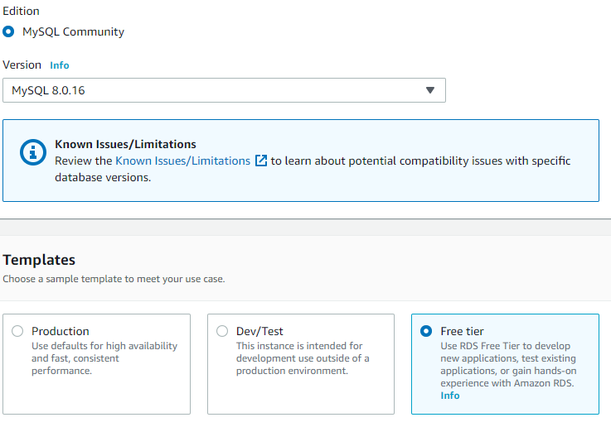  
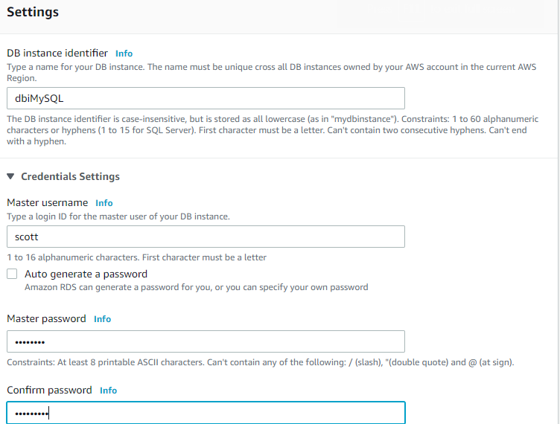

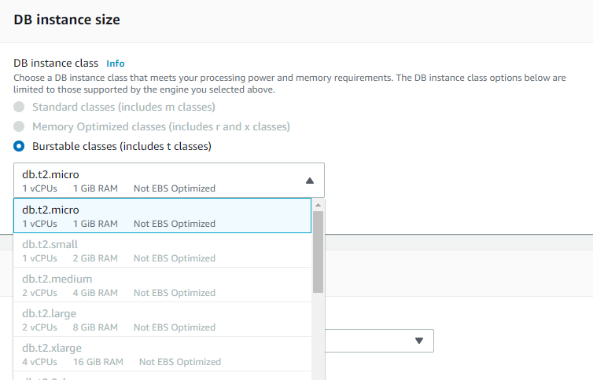  
  
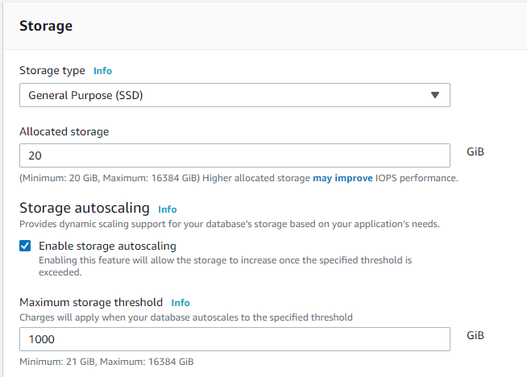  
  
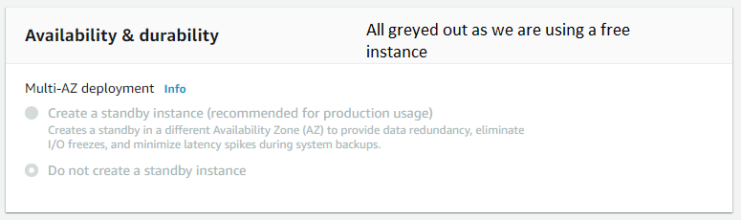  
  
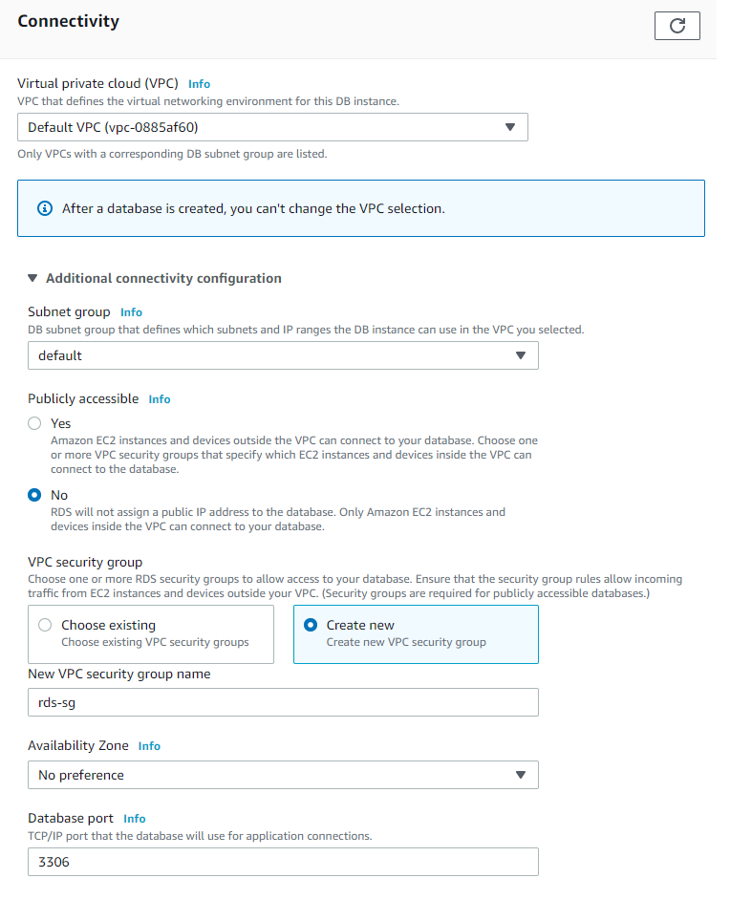  
Note : Notice the warning in the Backup section. It appears that automated backups are not supported for this MySQL free instance.If the automated backups are supported only – read replicas will work.  
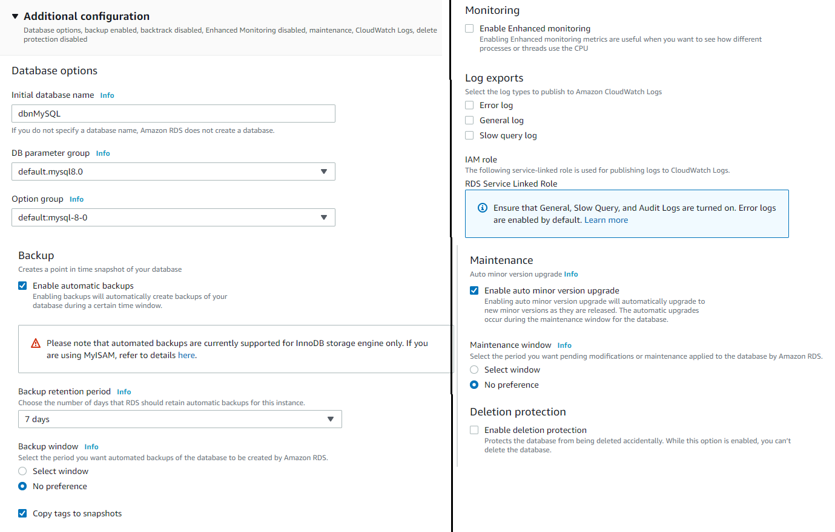

After the Database in created you can see as below.  
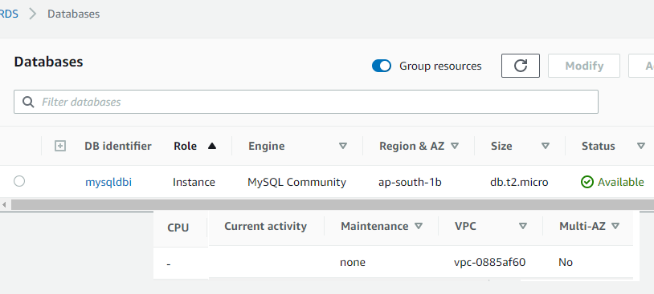  
A notice about the RDS resources you are using.  
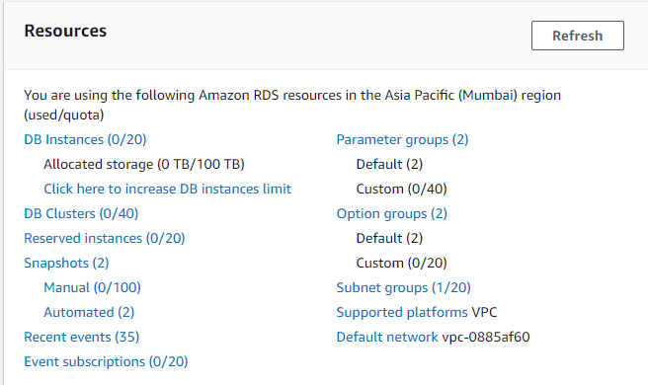  
  
When you click on your db instance it looks like below.  
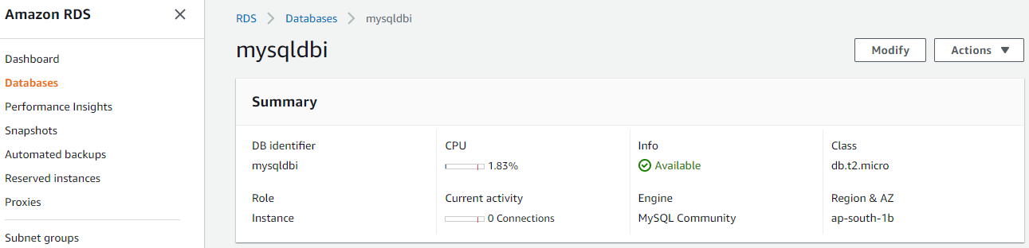  
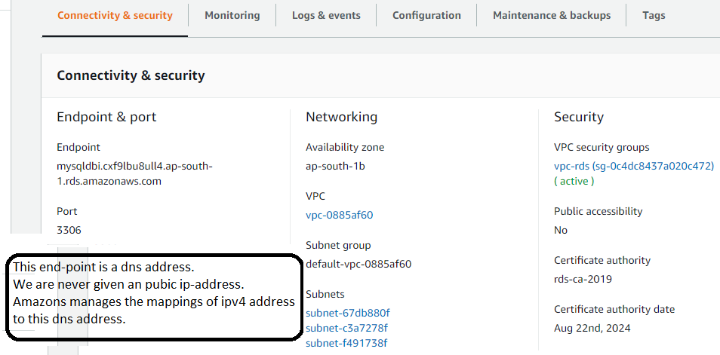  
 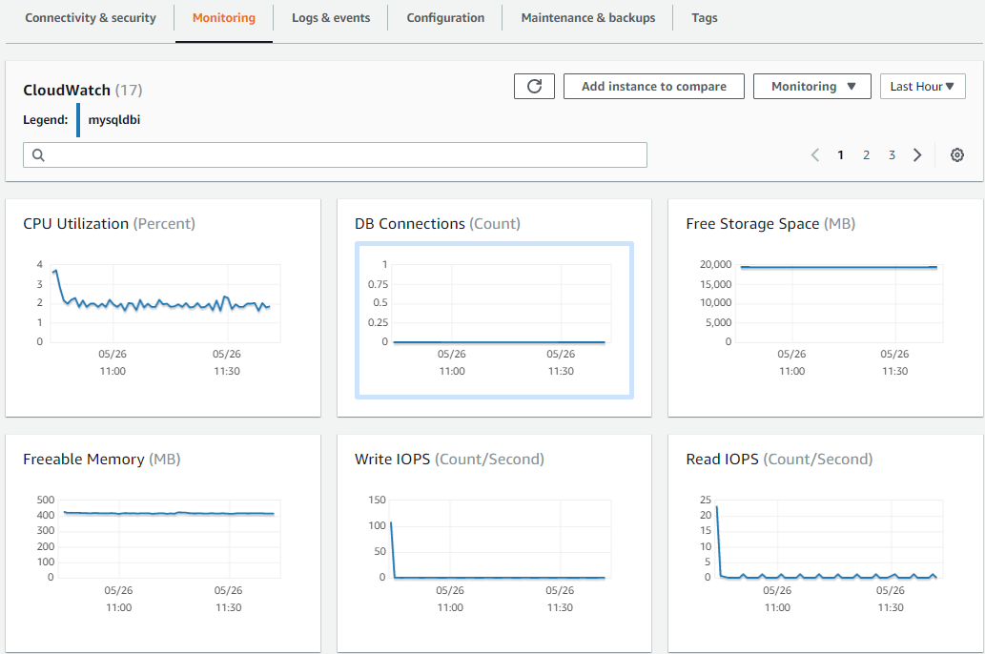

Now lets concentrate on connecting from EC2.   
Note : While configuring the rds we configured a new security group.  
 i.e We have two different entities in aws, ..  
 which are in two different security groups.  
  
Click on the configured security group shown below.  
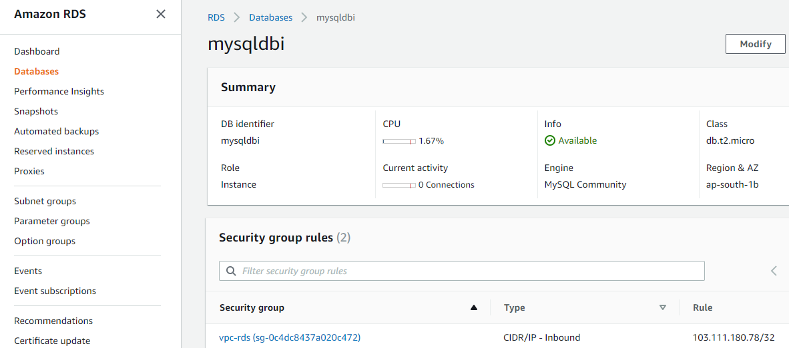  
  
This will take you to the EC2 page.  
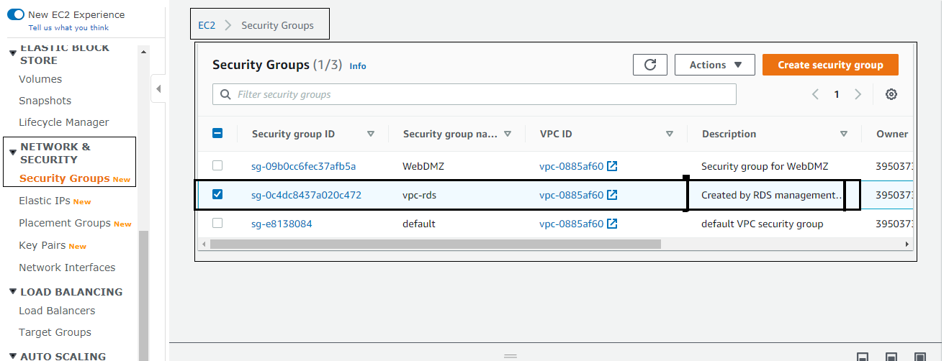

Select the security group created by RDS and edit the inbound rules.  
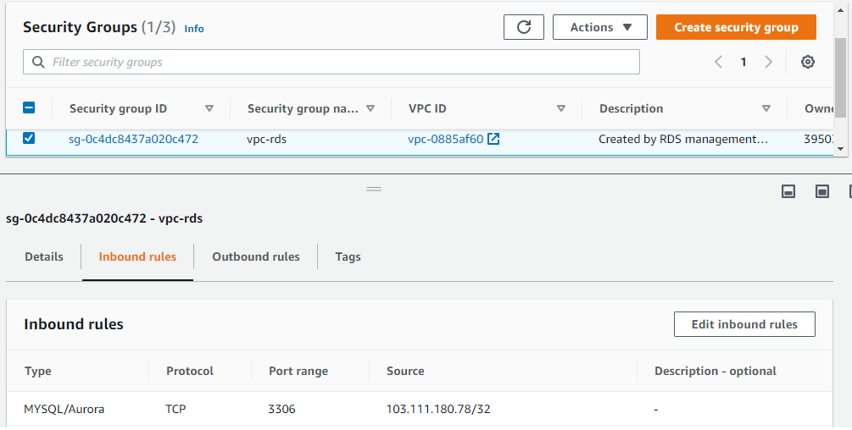

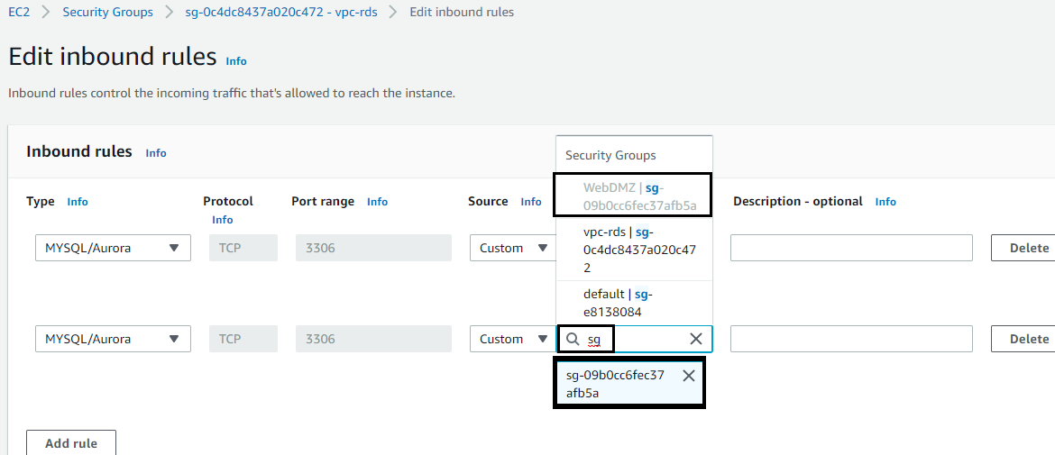  
  
Finally, the inbound rules for the security group configured by RDS will look as below.  
(We have allowed inbound traffic to port 3306 from the SG of our ec2 instance)

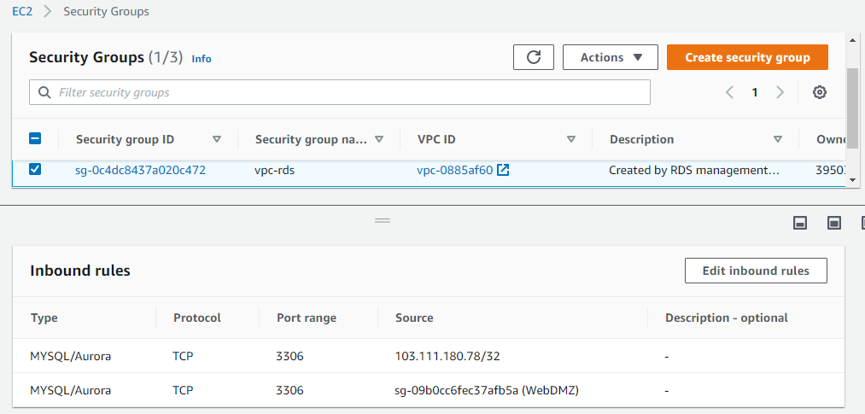

|  |
| --- |
| #!/bin/bash  yum install httpd php php-mysql -y  yum update -y  chkconfig httpd on  service httpd start  echo "<?php phpinfo();?>" > /var/www/html/index.php  cd /var/www/html  wget https://s3.amazonaws.com/acloudguru-production/connect.php  <?php  $username = "acloudguru";  $password = "acloudguru";  $hostname = "yourhostnameaddress";  $dbname = "acloudguru";  //connection to the database  $dbhandle = mysql_connect($hostname, $username, $password) or die("Unable to connect to MySQL");  echo "Connected to MySQL using username - $username, password - $password, host - $hostname<br>";  $selected = mysql_select_db("$dbname",$dbhandle) or die("Unable to connect to MySQL DB - check the database name and try again.");  ?> |

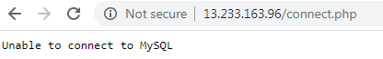 - Before the security group is configured.  
  


7. RDS : Multi AZ and Read Replicas  
  
Backups : There are two types of backups.  
Automated backups : Automated backups will take a full snapshot daily + store transaction logs through out the day.So when you recover aws will choose the most recent daily backup and apply those transaction logs that are relevant to that day. The retention period is 35 days.   
They are enabled by default.  
Data is stored in s3.  
You get free storage space in S3 which is equal to that of your database.  
The automated backups will be deleted as soon as the RDS instance is deleted.  
  
Database Snapshots :  
They are user initiated / manually taken.

They will still be available even if the original RDS instance is deleted.

Restore:  
After RDS backup is restored, we get a new DNS endpoint.

Encryption :

All the 6 db’s as part of amazon RDS supports **encryption at rest**.

Encryption is done using the aws KMS(key management service).

Once the ‘rds instance/database’ is encrypted, The data stored at rest in the underlying storage is encrypted.  
The automated backups, snapshots, read replicas are also encrypted.

How to take a manual snapshot. (Notice that the ‘create read replica’ option is disabled, This needs automated backup option to be enabled in the rds instance)  
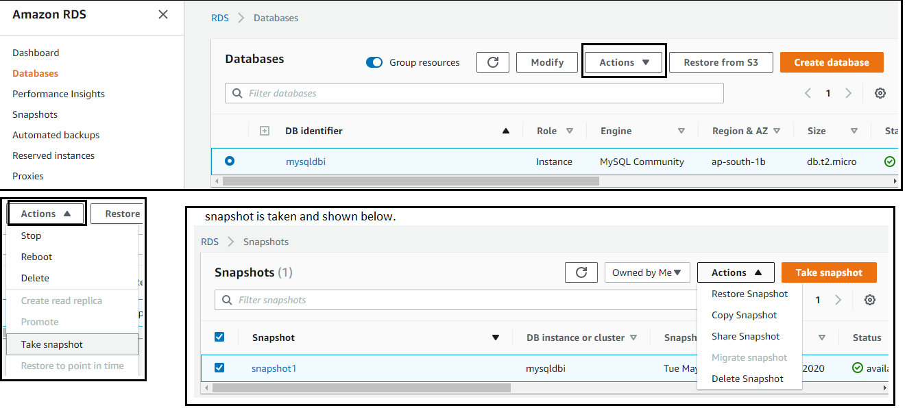  
  
  
  
  
  
  
  
  
  
  
Encrypting an (already ?) existing DB instance is not supported.  
For that we must create a snapshot, make a copy(above screenshot menu option) of that snapshot, and encrypt the copy.The above DB was created without encryption. We can encrypt the db in this way.  
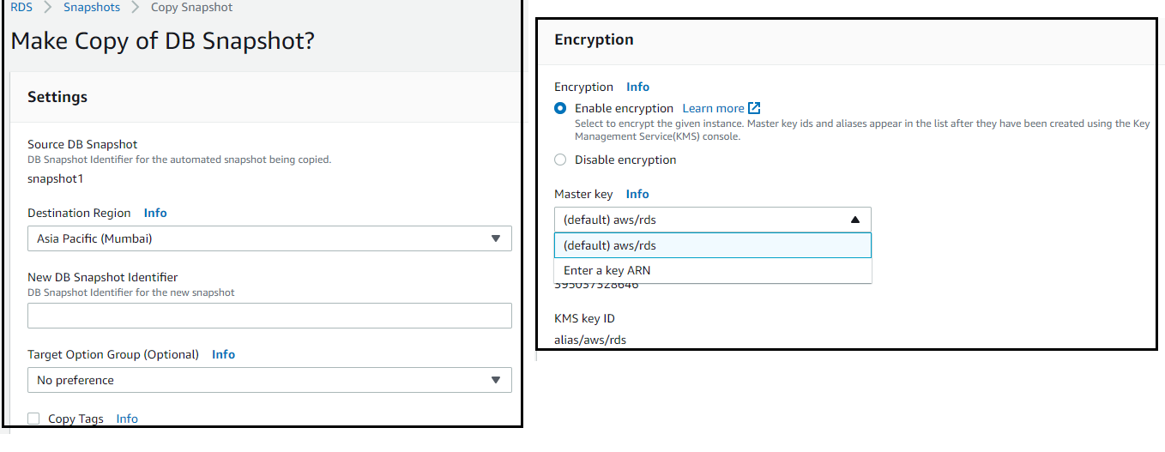

MULTI-AZ VS READ-REPLICAS

Multi-AZ : High – availability.  
 With this we have an exact copy of your database in another availability zone.  
 It is used only for **disaster recovery** (In the event of planned db maintenance / or  
 availability zone failure / or db instance failure).  
 This feature is available for all the 6 DB’s.  
  
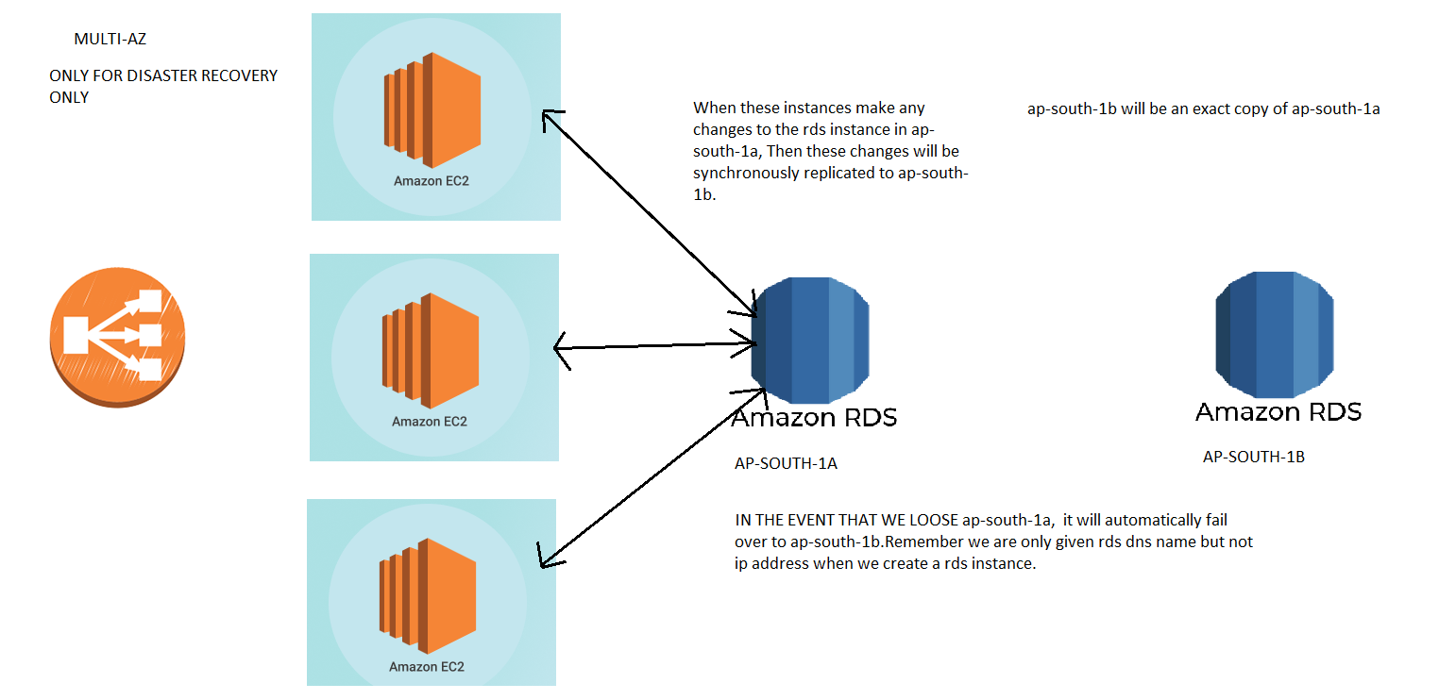

Read Replica:  
Only available for MySQL, MariaDB, Aurora, PostgreSQL.  
Scale-out.  
Automatic backups must be turned on – for read replica to be deployed.  
This is used for performance improvement.  
They allow you to have a read-only copy of your database. This is achieved using Asynchronous replication of the primary RDS instance.  
  
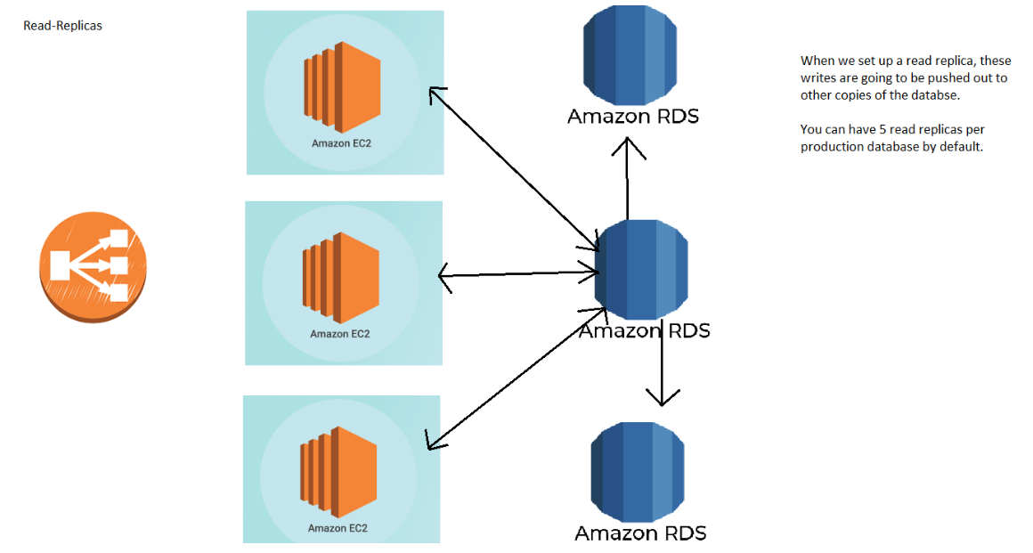  
  
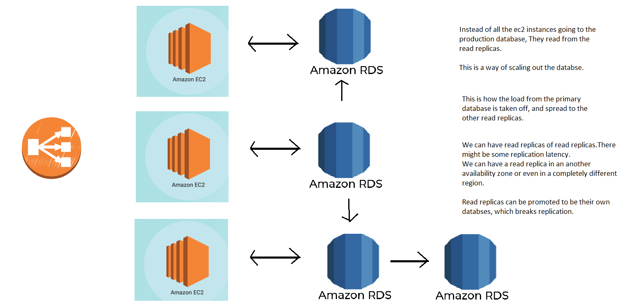  
  
A screen shot from the aws rds-read replica page.  
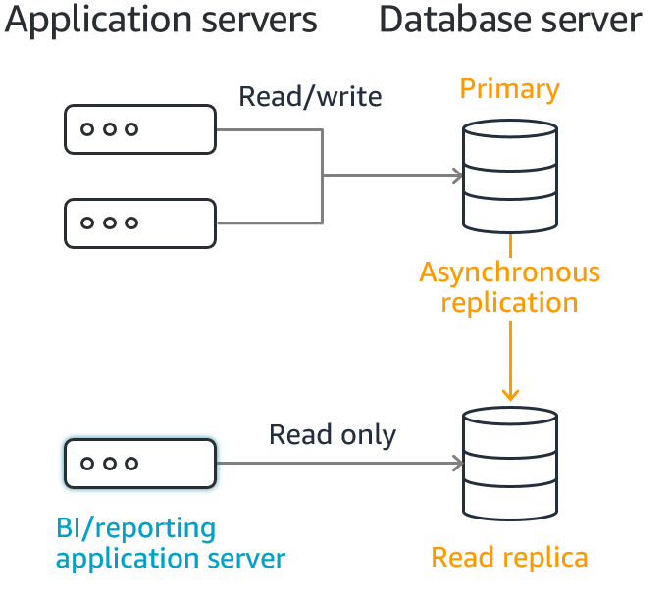

How to enable Read-replica and Multi-AZ from the console.  
I have created another **MariaDB** instance and it has the ‘create-read replica’ option enabled.  
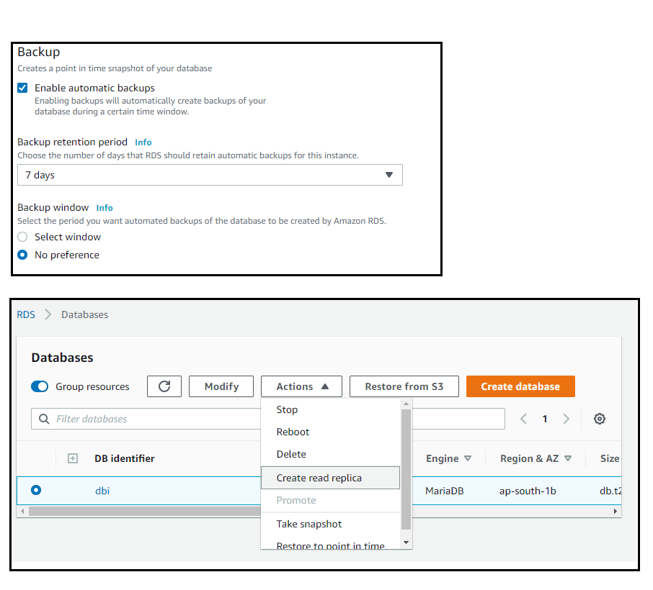  
  
What are the options shown to you while creating the read-replica.  
  
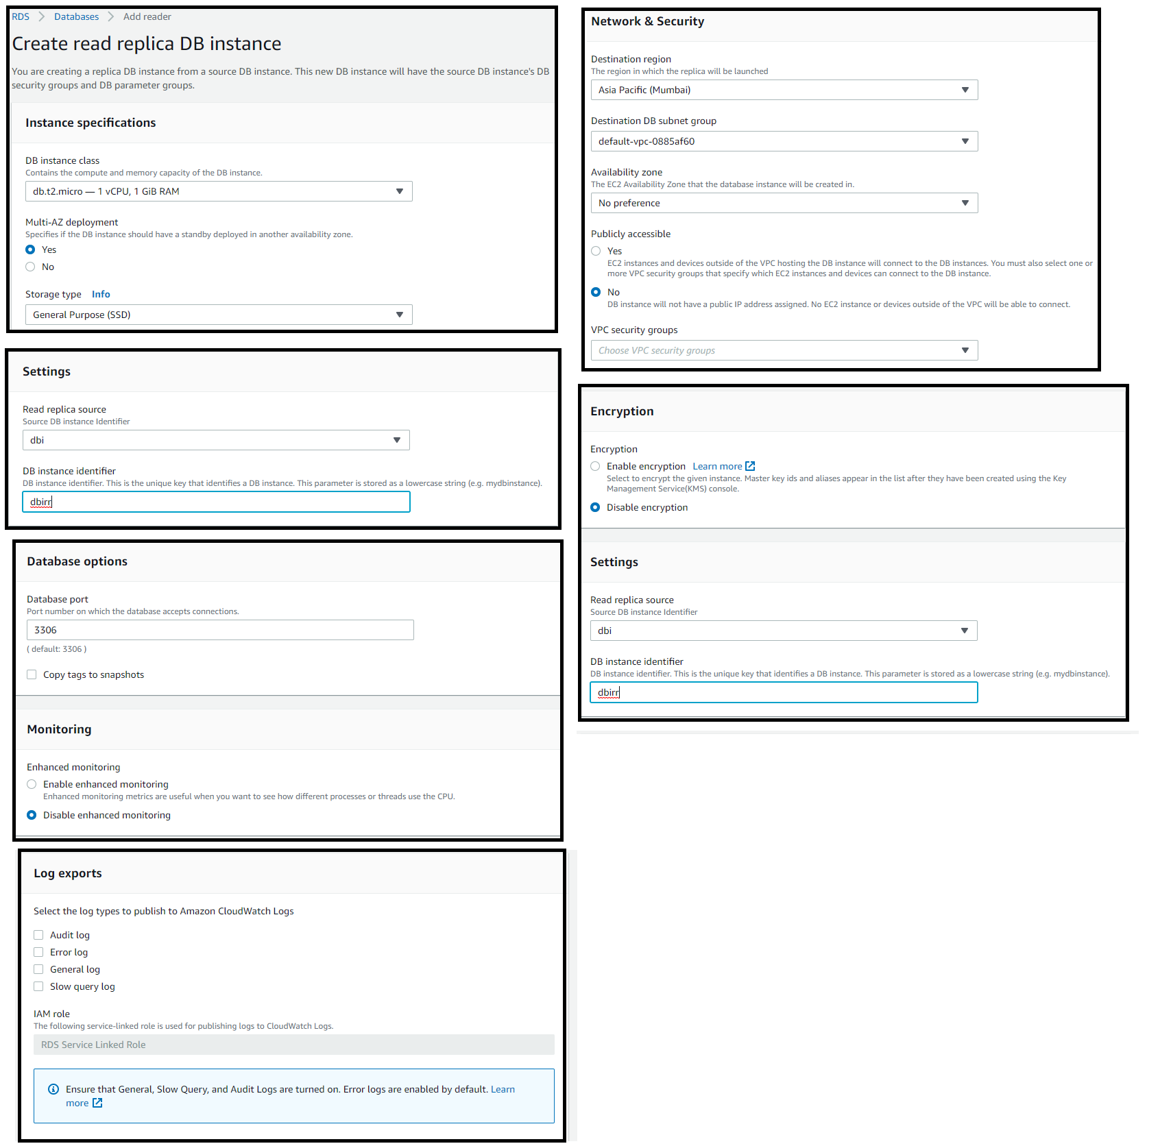  
  
After the read-replica is created the dash board will look like below.  
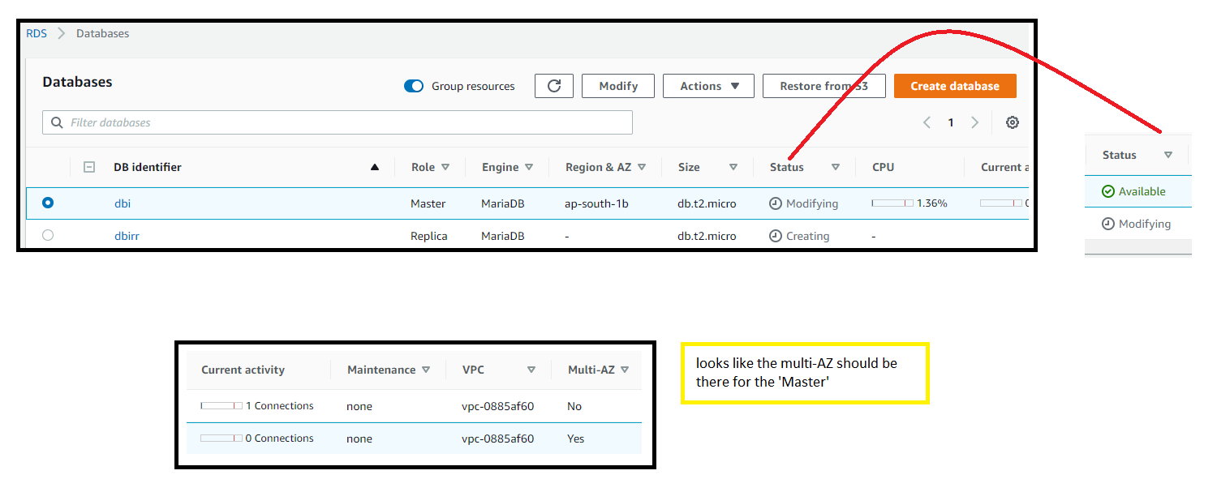  
  
Note that you can promote the read-replica as a master.  
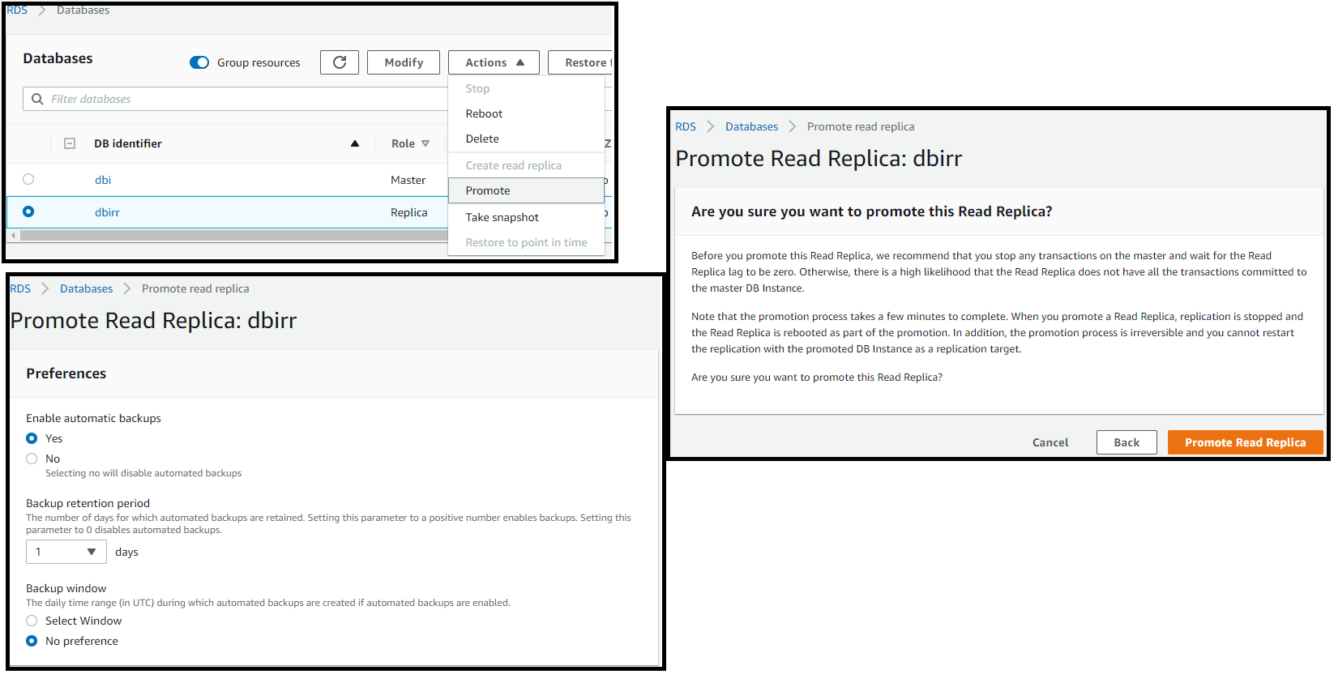

7.ELASTICACHE – THEORY

- Elasticache is a web service that allows you to deploy, operate, and scale an in-memory cache in the cloud.

- It improves the performance of you web application, by allowing you to retreive information from fast managed in-memory caches instead of relying on slower disk-based databases.

- ex: caching your most frequently used queries.

- improves latency and throughput for many read-heavy workloads such as social n/wing, media sharing etc

How - ? Caching improves the performance by storing critical pieces of data in memory for low latency access. The cached information could be the results of I/O-intensive database queries or the results of computationally intensive calculations.  
- The more you cache – the more you free your database.  
- REMEMBER TO USE REDSHIFT RATHER THAN ELASTICACHE FOR ONLINE ANALYTICS PROGRAMMINg (RELATED TO DATA WARE HOUSING)  
  
Types of elasticache  
- Elasticache supports Master/Slave Replication AND Multi-AZ

MemCacheD   
- it is a memory object caching system.  
- Elasticache is protocol compliant with memcached.  
- i.e the popular tools that you use with existing memcached environments will work seanmlessly with the elasticache-memcached service.  
- If you are not concerned about redundancy use MemcacheD  
- MemcacheD is designed as a pure caching solution with **no-persistence**.  
- Elasticache manages MemcacheD nodes as a pool that can grow and shrink, similar to EC2 auto scaling group.(auto-scaling : when we get to a certain load, an instance will be added behind the load balancer.)  
- use cases : u want to off load your database ? / simple caching model ? / large cache nodes and require multi-threaded performance with utilization of multiple cores ? / want to scale out horizontally as you grow.

Redis  
- It is an open source in-memory **key-value store** that supports ds’s sets and lists.  
- Use redis if you want Multi-AZ access.  
- Use case : looking for more advanced data types like sets and lists ? / Sorting and ranking datasets in memory ? /is persistence of your key store important ? / Do you want to run in multiple-AZ’s with failover ? /  
- The data on Redis is **persisted** even after re-boot.  
  
Note : Because of the replication and persistence features of redis, elasticache manages redis more as a relational database. Redis-elasticache clusters are managed as stateful entities that include failover, similar ot how rds manages database failover.  
   
8. What does billing look like at the moment.  
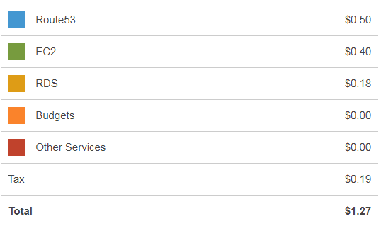   
I was charged for the RDS mysql/MariaDB instances created above.